PROJECT DESIGN PHASE-II
Technology Stack (Architecture & Stack)
Date
Team ID
Project Name | Weatherwise
Maximum Marks | 4 Marks

Technical Architecture
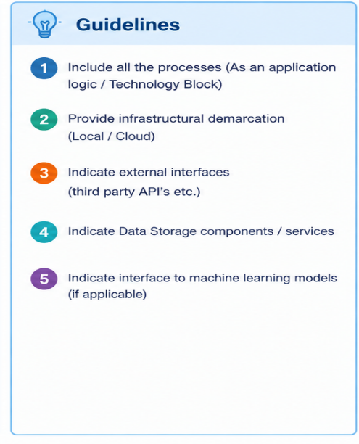
The Weatherwise application follows a simple web-based architecture. The user interacts with the Weatherwise interface to search for a location. The application processes the request and communicates with an external weather API to retrieve weather information. The received data is processed and displayed to the user.
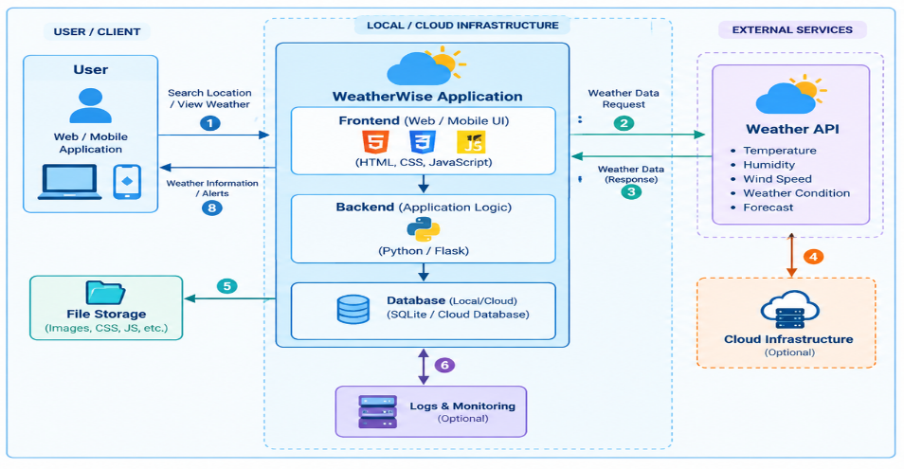
Architectural Diagram

Architecture Components
- User Interface: Provides the interface through which users search for locations and view weather information.
- Application Logic: Processes user requests and communicates with the weather API.
- External API: Provides real-time weather information.
- Database: Stores required application data and configuration information.
- Local/Cloud Infrastructure: Provides the environment for running and deploying the Weatherwise application.
The template specifically requires processes/application logic, infrastructure demarcation, external interfaces, data storage, and machine-learning interfaces where applicable.
Table-1: Components & Technologies
S. No | Component | Description | Technology
1 | User Interface | Interface through which users search locations and view weather information. | HTML, CSS, JavaScript
2 | Application Logic-1 | Processes user location/search requests. | Python
3 | Application Logic-2 | Handles API requests and processes weather data. | Flask / Python
4 | Application Logic-3 | Displays processed weather information such as temperature, humidity and wind. | Python / Flask
5 | Database | Stores application-related data and configuration information. | SQLite
6 | Cloud Database | Cloud database for storing application data if cloud deployment is used. | Cloud Database / Optional
7 | File Storage | Stores application files such as images, CSS and JavaScript files. | Local File System
8 | External API-1 | Provides current weather information for selected locations. | Weather API
9 | External API-2 | Provides additional forecast or weather-related information if required. | Weather Forecast API
10 | Machine Learning Model | Weatherwise does not require a machine-learning model for basic weather information retrieval. | Not Applicable
11 | Infrastructure (Server / Cloud) | Application deployment and execution environment. | Localhost / Cloud Server
This follows the same component categories as the original template: User Interface, Application Logic, Database, Cloud Database, File Storage, External APIs, Machine Learning Model and Infrastructure.
Table-2: Application Characteristics
S. No | Characteristics | Description | Technology
1 | Open-Source Frameworks | Open-source frameworks and technologies are used to develop the Weatherwise application. | Python, Flask, HTML, CSS, JavaScript
2 | Security | Input validation and secure handling of API requests are implemented to protect the application. | HTTPS, API Key Protection, Input Validation
3 | Scalable Architecture | The application follows a simple layered architecture separating the user interface, application logic and external data service. | Flask / Three-Tier Architecture
4 | Availability | The application depends on the availability of the application server and external weather API. | Local Server / Cloud Server
5 | Performance | API requests are processed efficiently and only required weather information is retrieved and displayed to the user. | Python, Flask, API Optimization
The template's Table-2 specifically covers Open-Source Frameworks, Security, Scalable Architecture, Availability, and Performance, so these same categories are retained here.
Technology Stack Summary
Layer | Technology Used
Frontend | HTML, CSS, JavaScript
Backend | Python
Framework | Flask
Database | SQLite
External Service | Weather API
Development Environment | VS Code
Browser | Google Chrome / Microsoft Edge
Deployment | Localhost / Cloud Server

